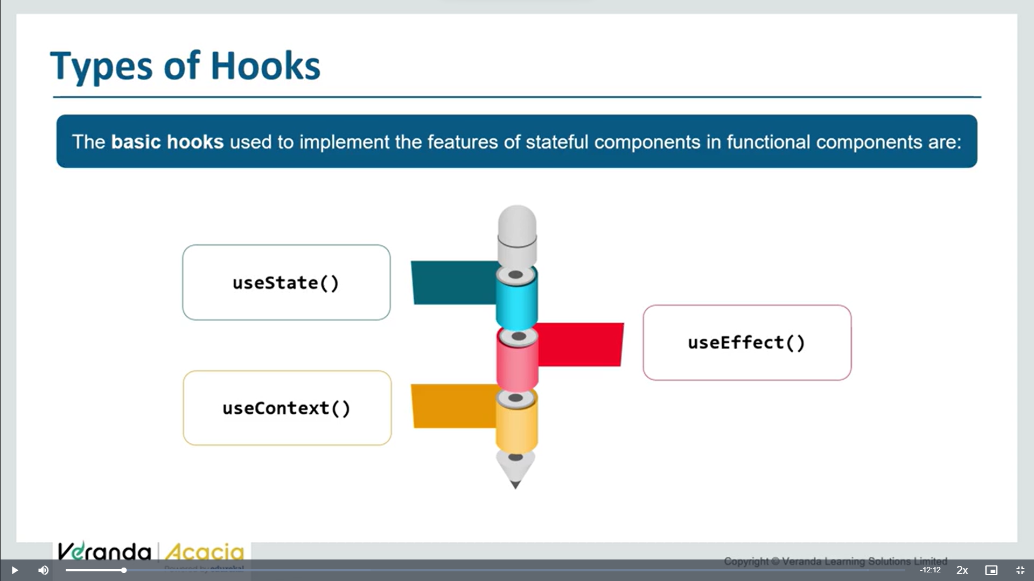

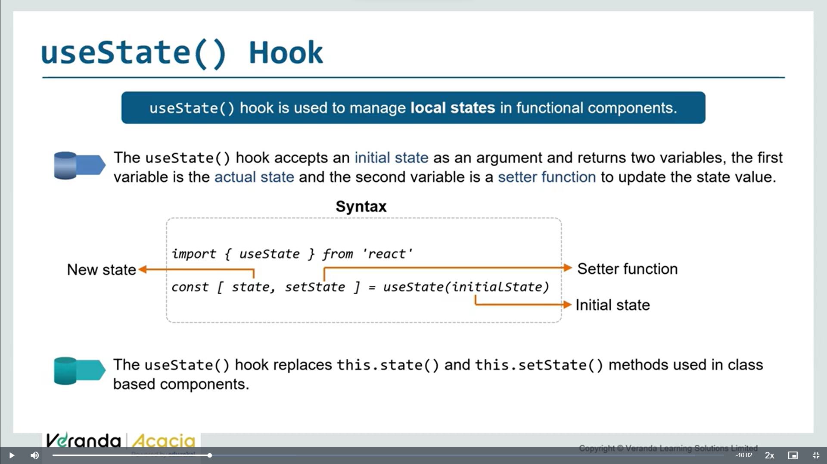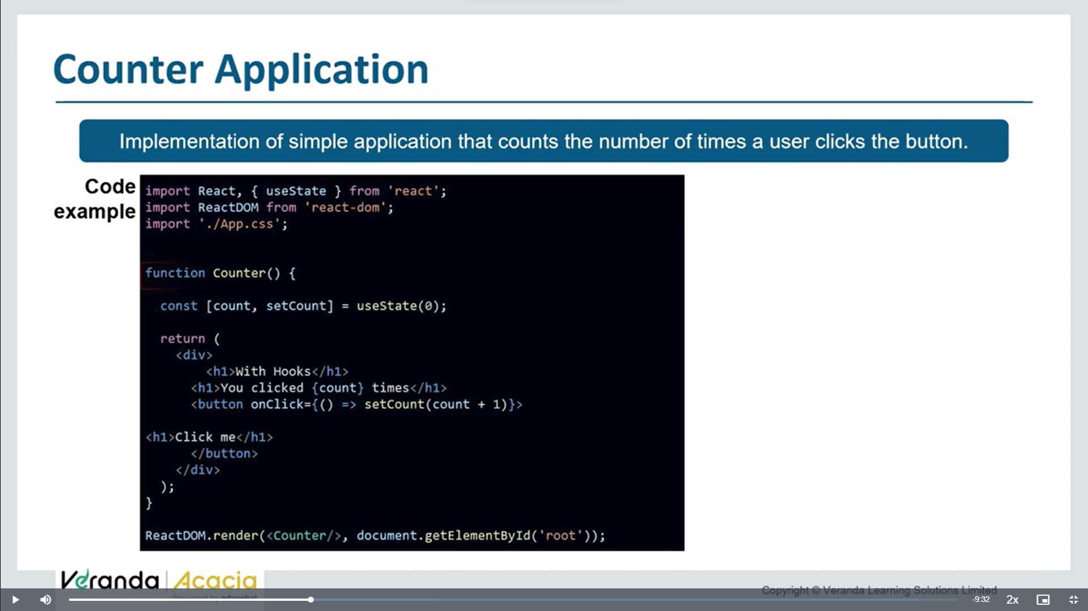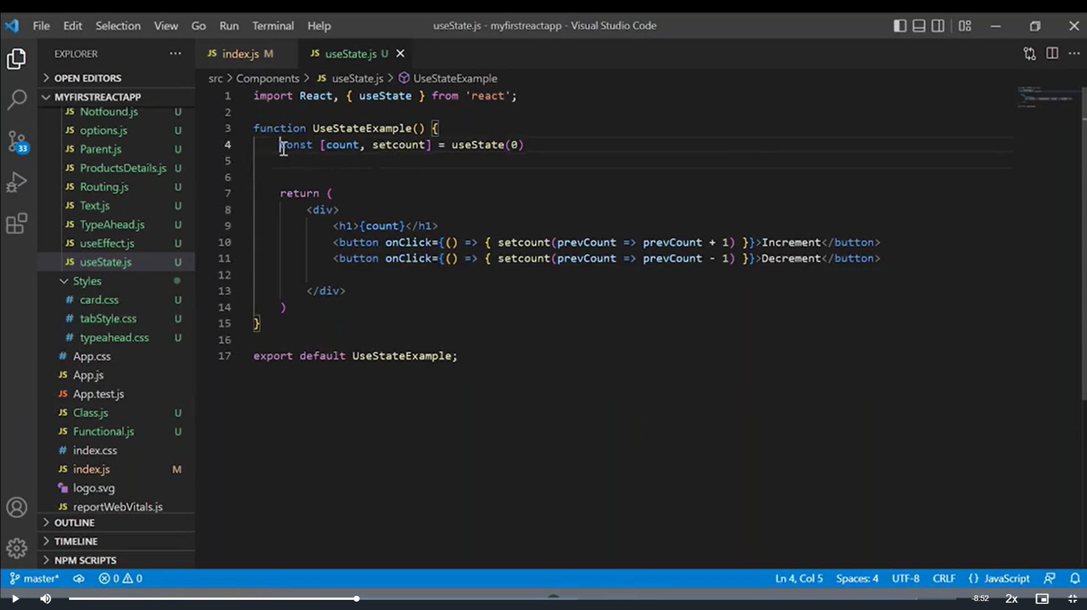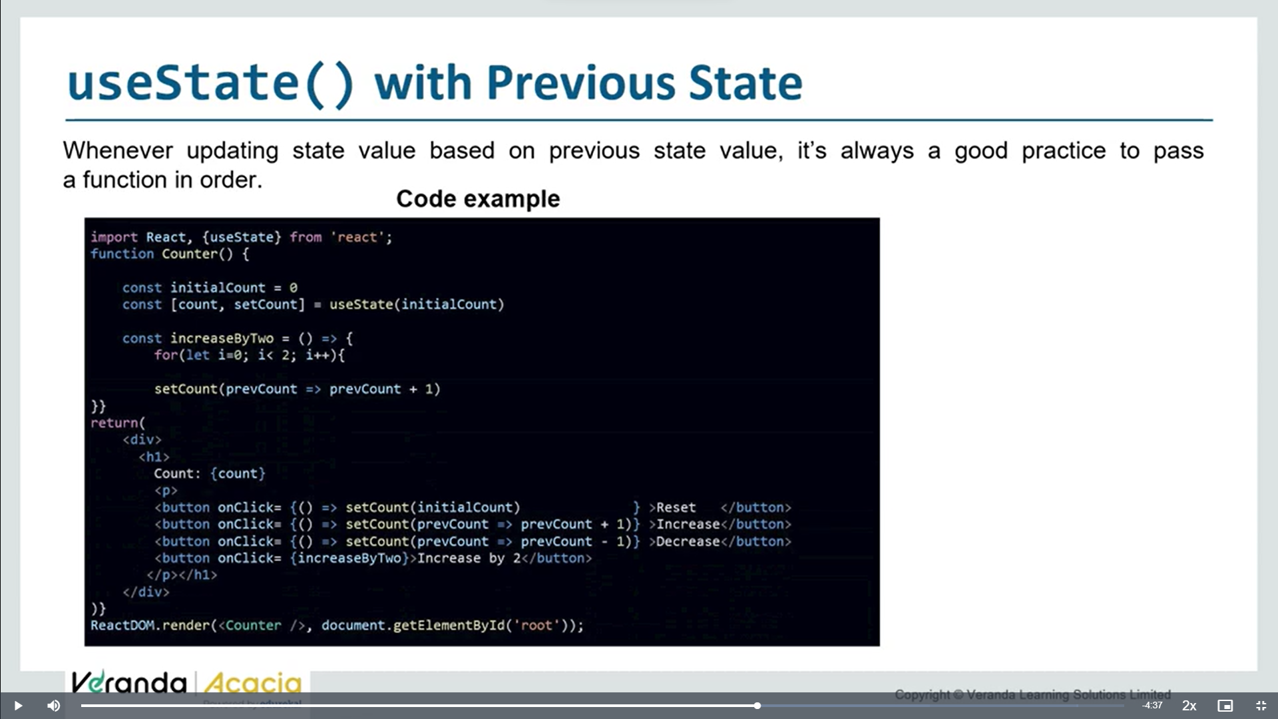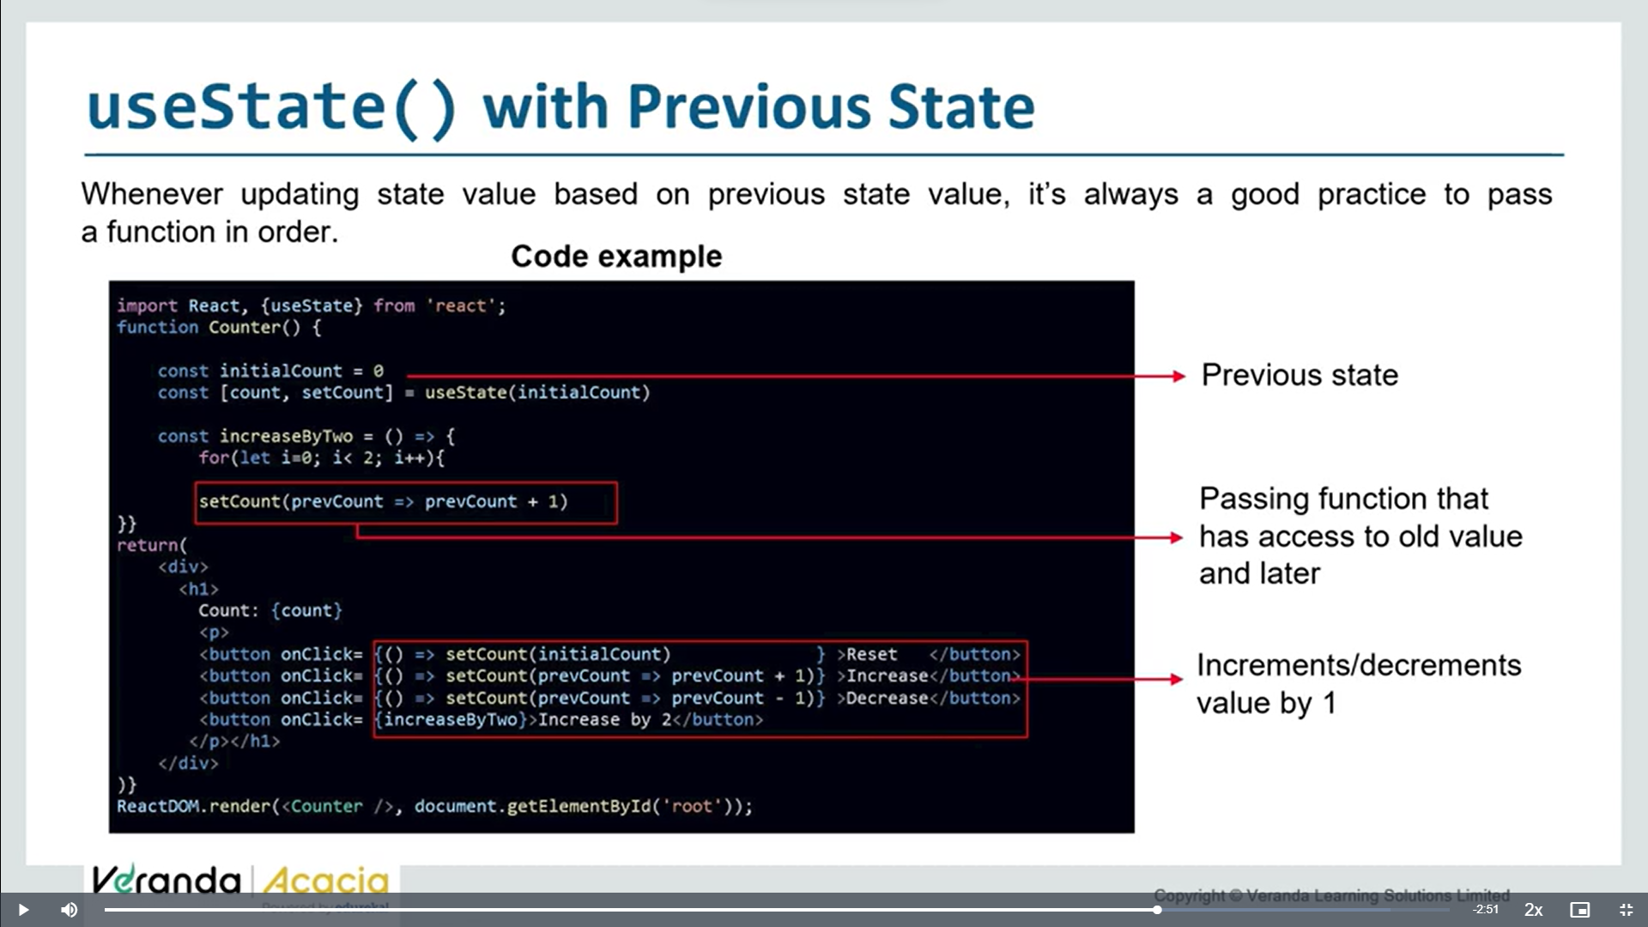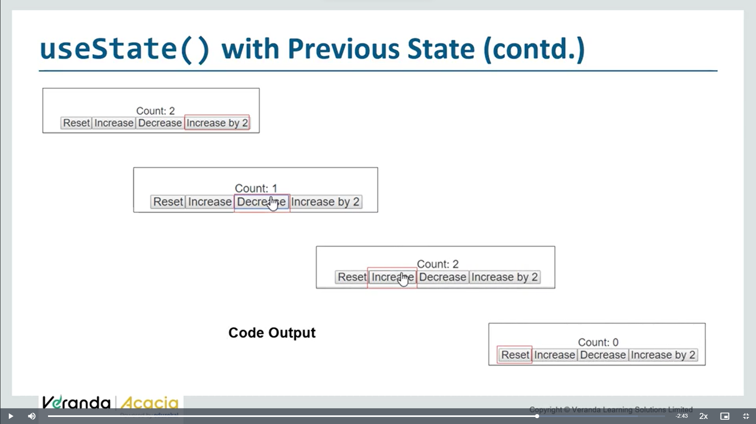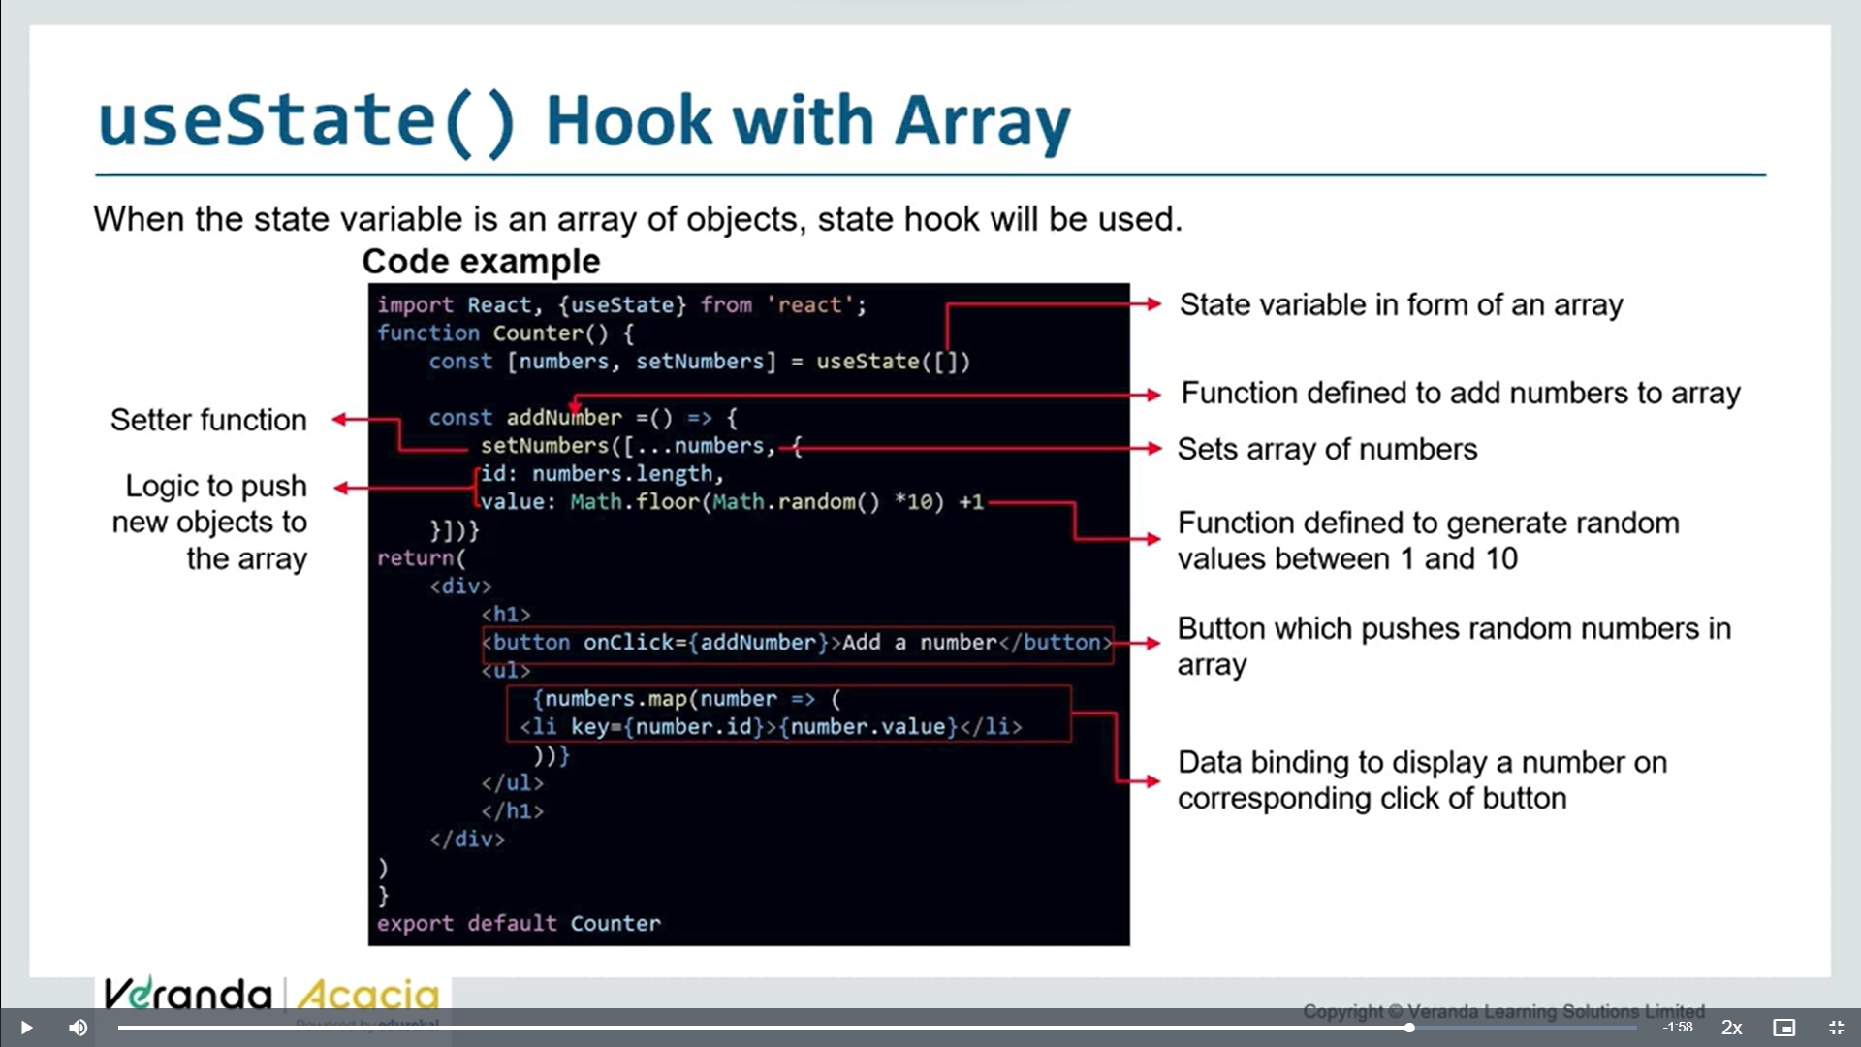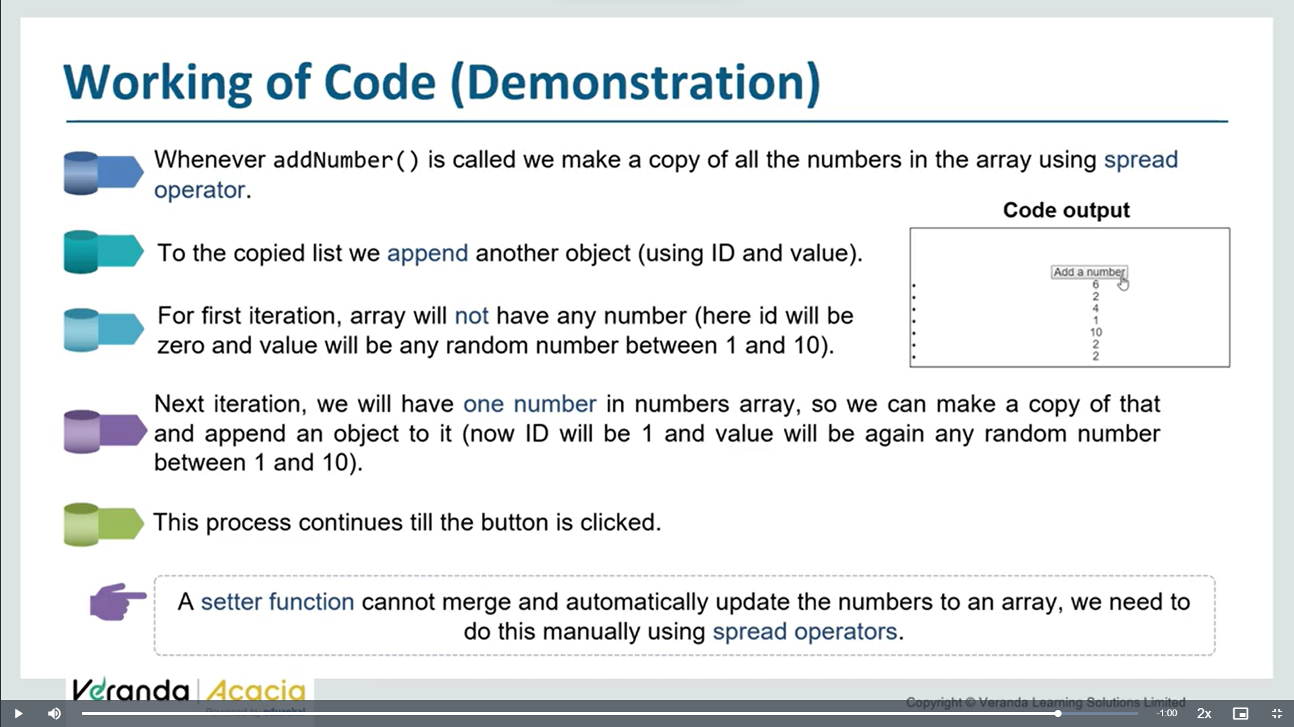

**Useeffect:**

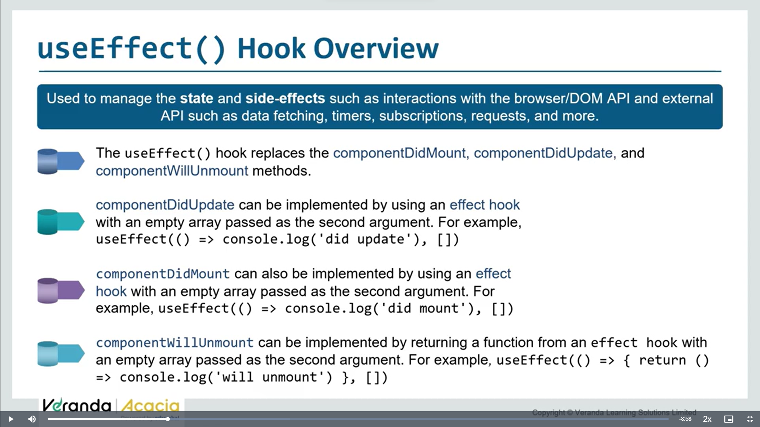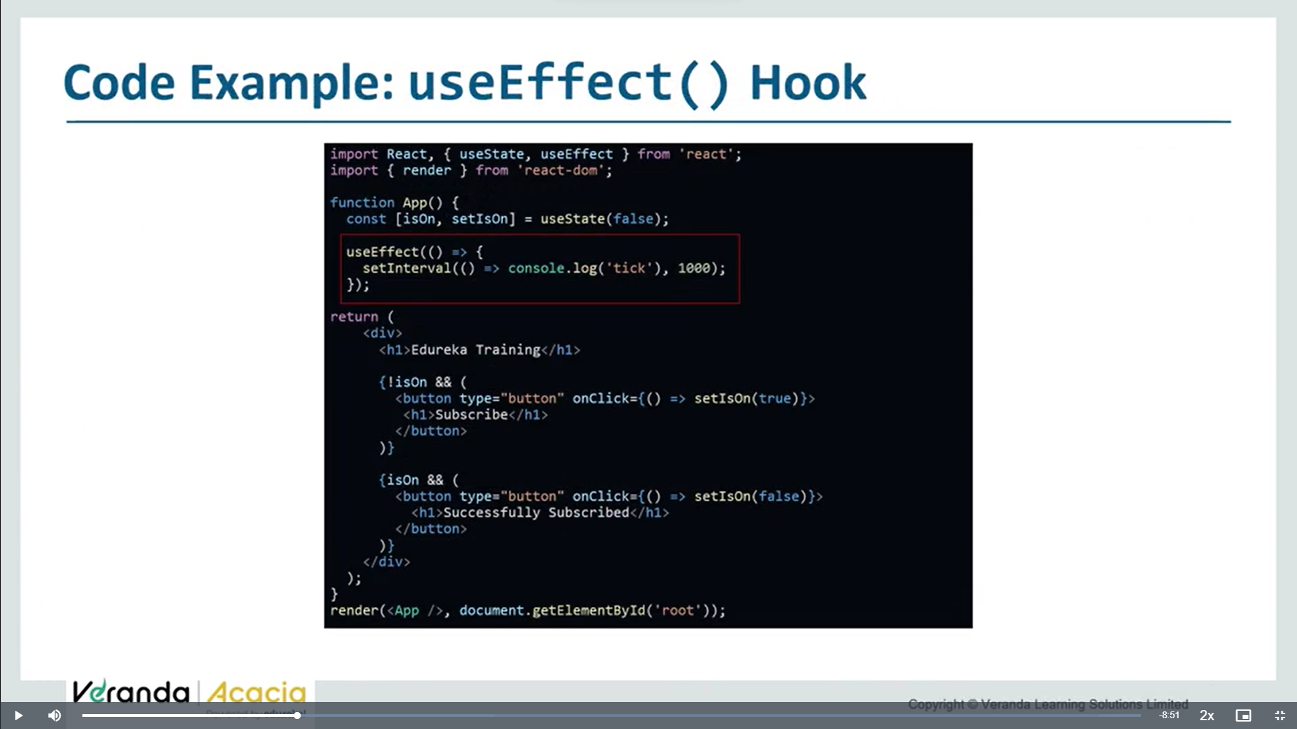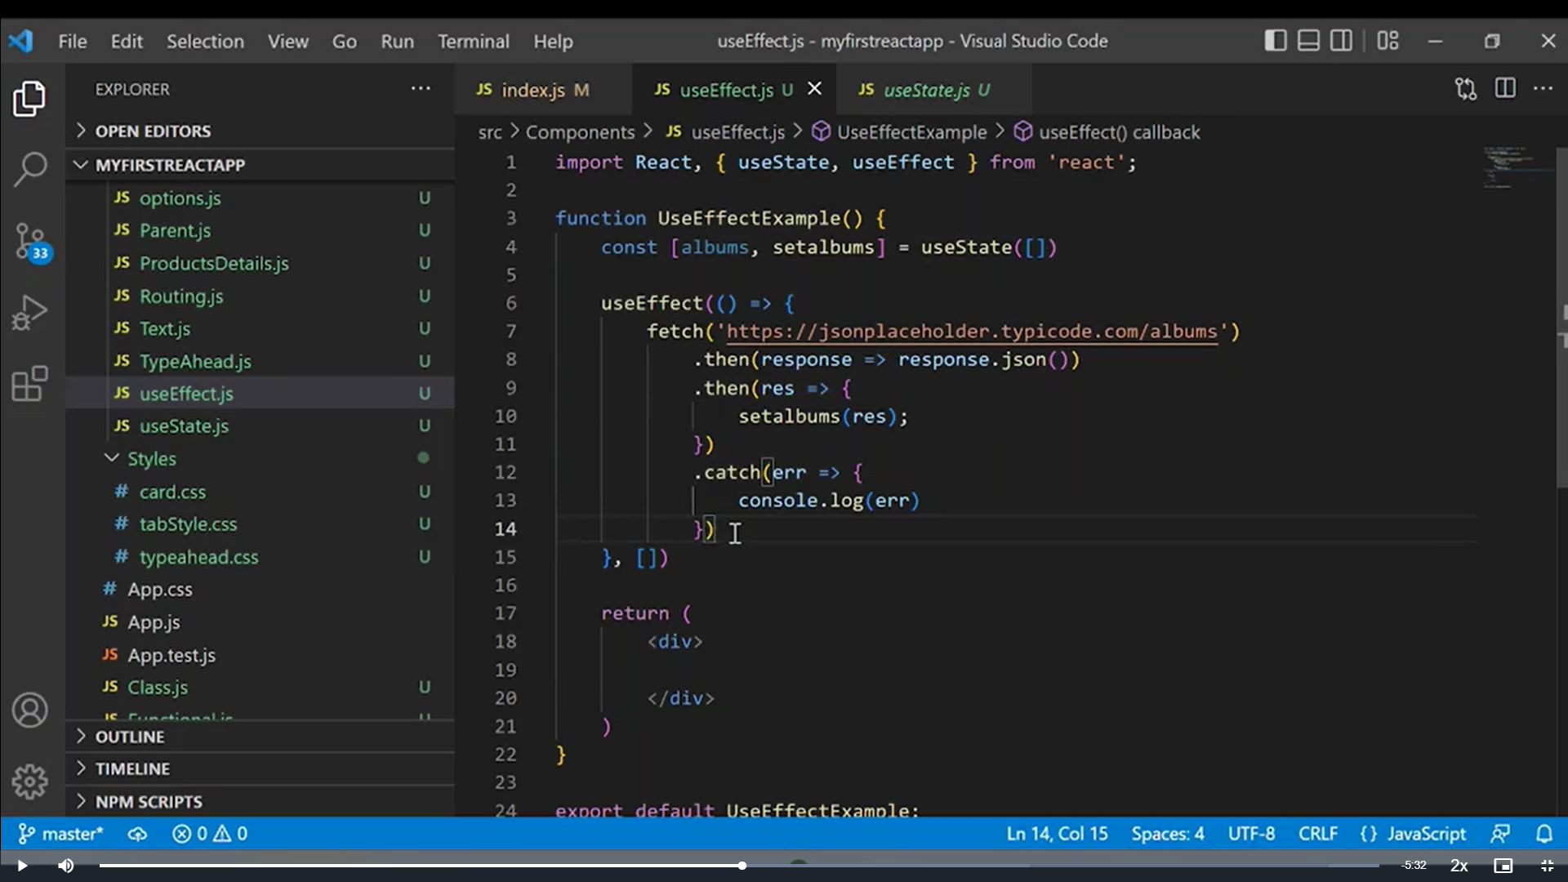

**This api calling useeffect() is replacing componentdidmount() , as in class components we write fetch in componentdidmount()**

**When ever , we want to run useeffect on each mounting(load) of component- make useeffect() to behave as componentdidmount by passing empty array.**

**Albums is array of objects so use map to iterate**

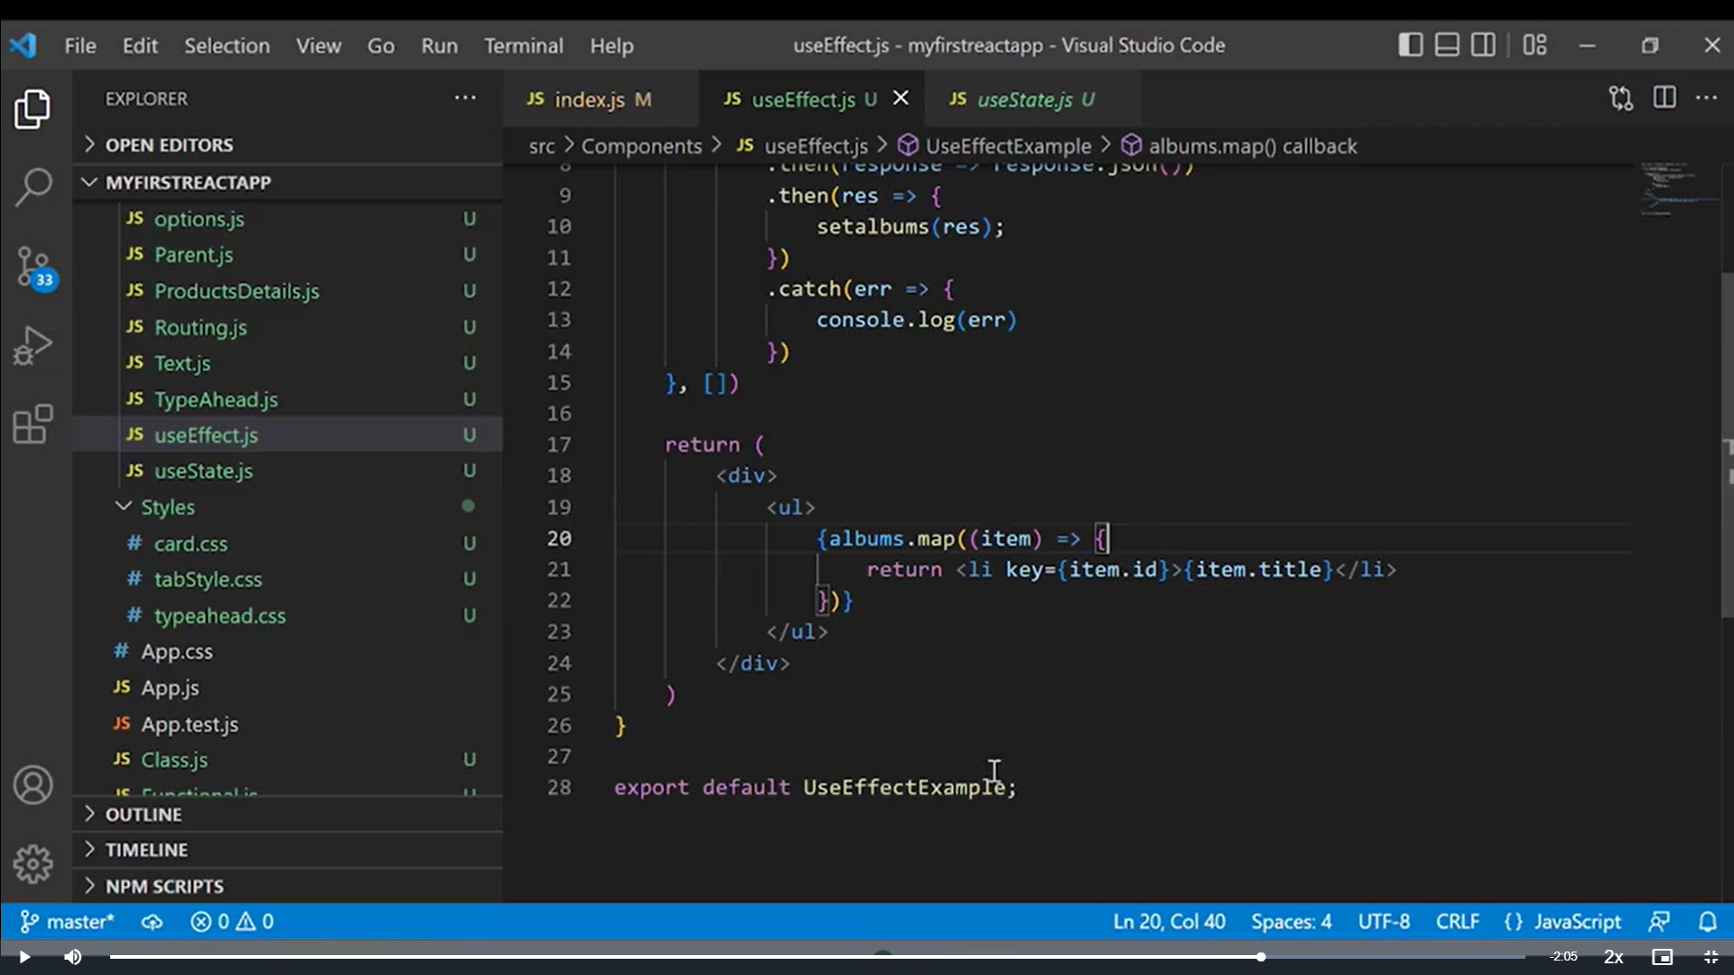

**Axios:**

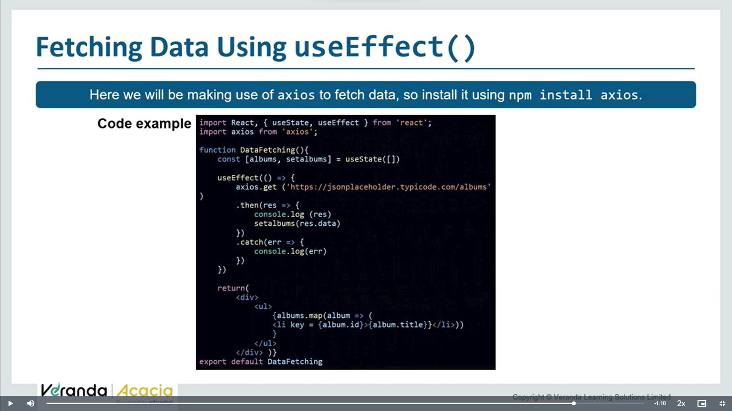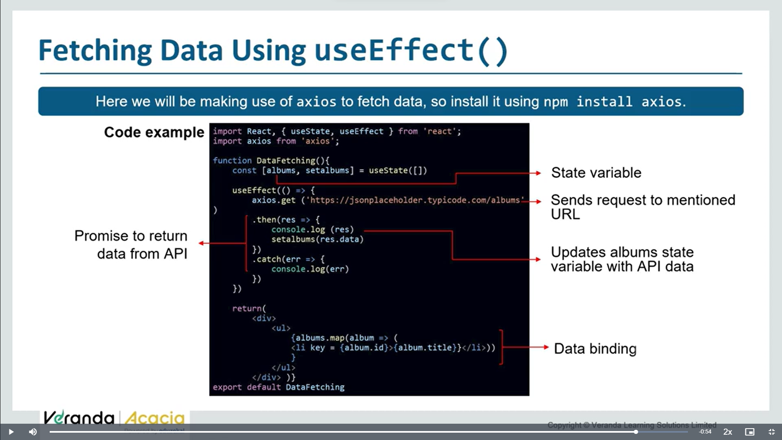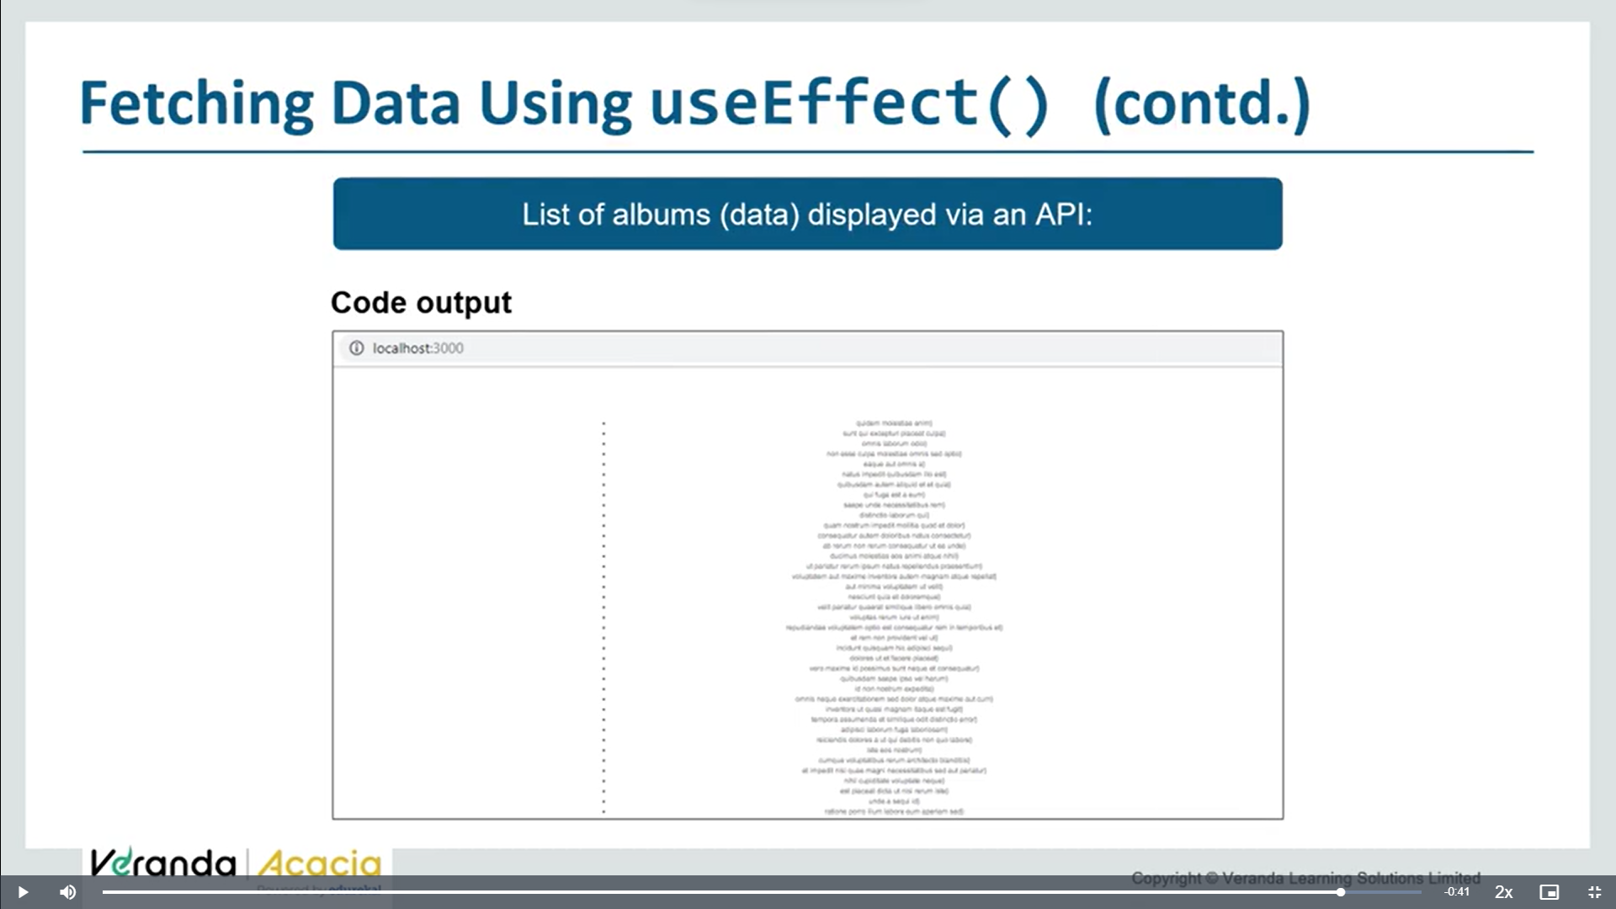

**Axios vs fetch:**

Overall, while both Fetch and Axios can be used to make HTTP requests in React-Native, Axios may be a better choice if you want a simpler way to work with the response data, as it automatically parses the response and returns the data directly.

No need of conversion .json()

**Axios performs automatic transforms of JSON data**.

|  |
| --- |
| Fetch is a two-step process when handling JSON data- first, to make the actual request; second, to call the .json() method on the response. |
|  |

Diy- usestate () and useeffect()

**Tutorial** : https://youtu.be/tGXbiU2jcs4?si=9H004Vbcqy7XSHhf

Useeffect() hook is to perform actions which takes time like, timer funcs- settimeout,setinterval

Or to update dom directly or to fetch data

All these tasks to perform we use this hook.

* If u are familiar with class components , u can think of useeffect() hook as componentdidmount,componentdidupdate, and component willunmount combined

Eg:

App.jsx

import { useState } from 'react'

import reactLogo from './assets/react.svg'

import viteLogo from '/vite.svg'

import './App.css'

function App() {

  const [count,setCount]=useState(0);

  function updateCount(){

    setCount(count+1);

  }

  return (

    <>

    <h1>button clicked {count}  times</h1>

    <button onClick={updateCount}>Click</button>

    </>

  )

}

export default App

mostly whenever we use useeffect(), we use it in combination with useState()

output:

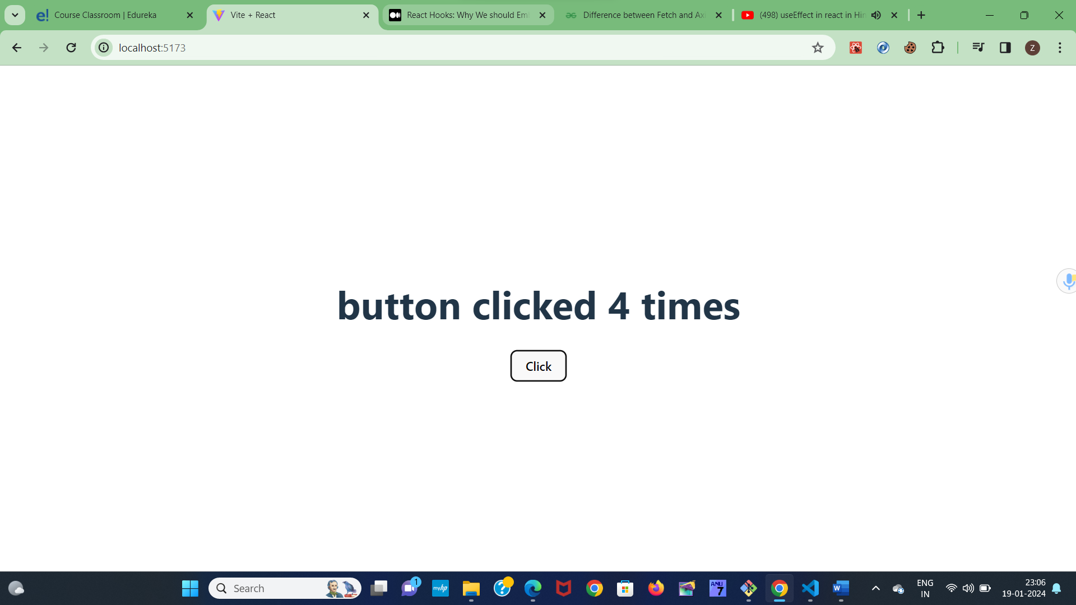

Useeffect() hook takes 2 args, one callback func( sideeffect func ) – it can be timer func, or fetching func or any.

2nd arg – array – optional parameter

  const [count,setCount]=useState(0);

  useEffect(()=>{

    console.log('component mounted')

  })

Check output, on each reload useeffect() hook is running – getting console

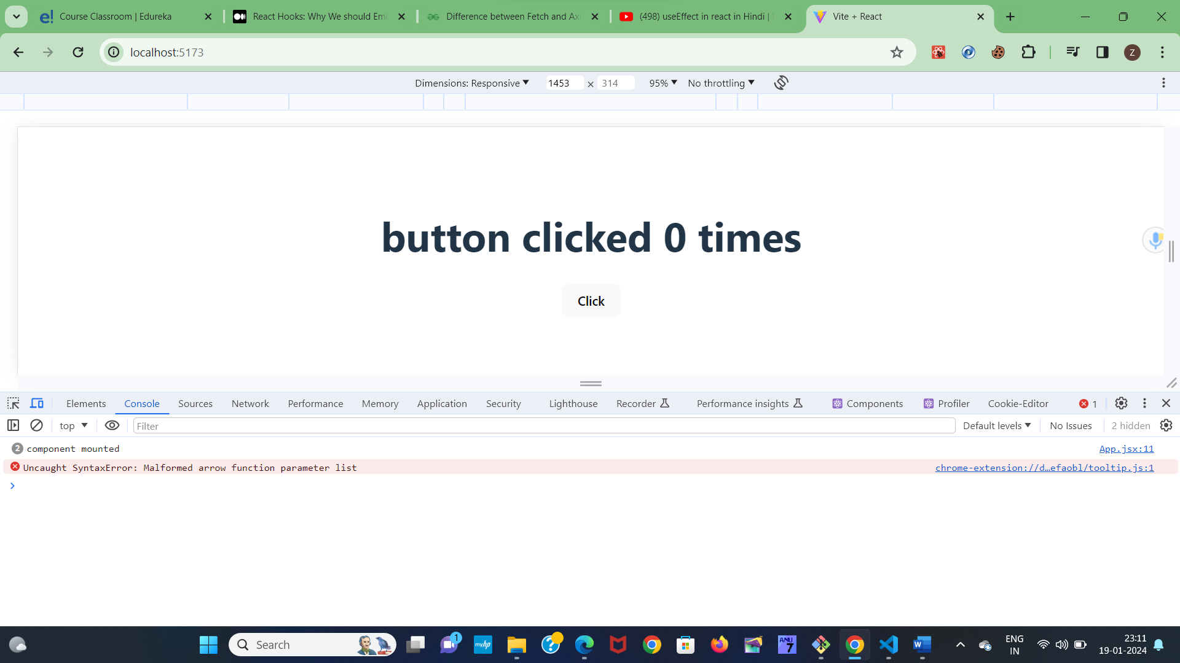

Onrefresh output will be

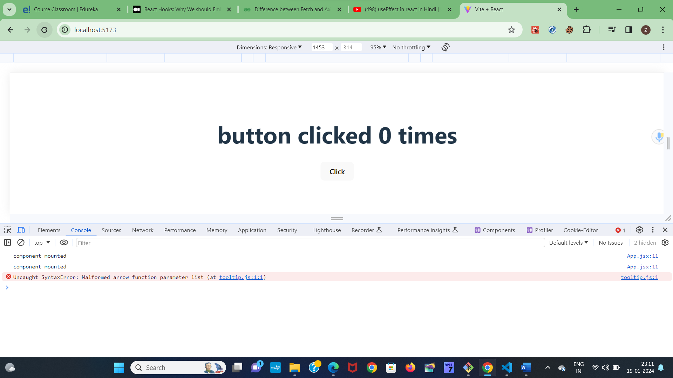

So whenever our page refersh, useeffect will get rendered

Check below on clicking button also, useeffect is rendering

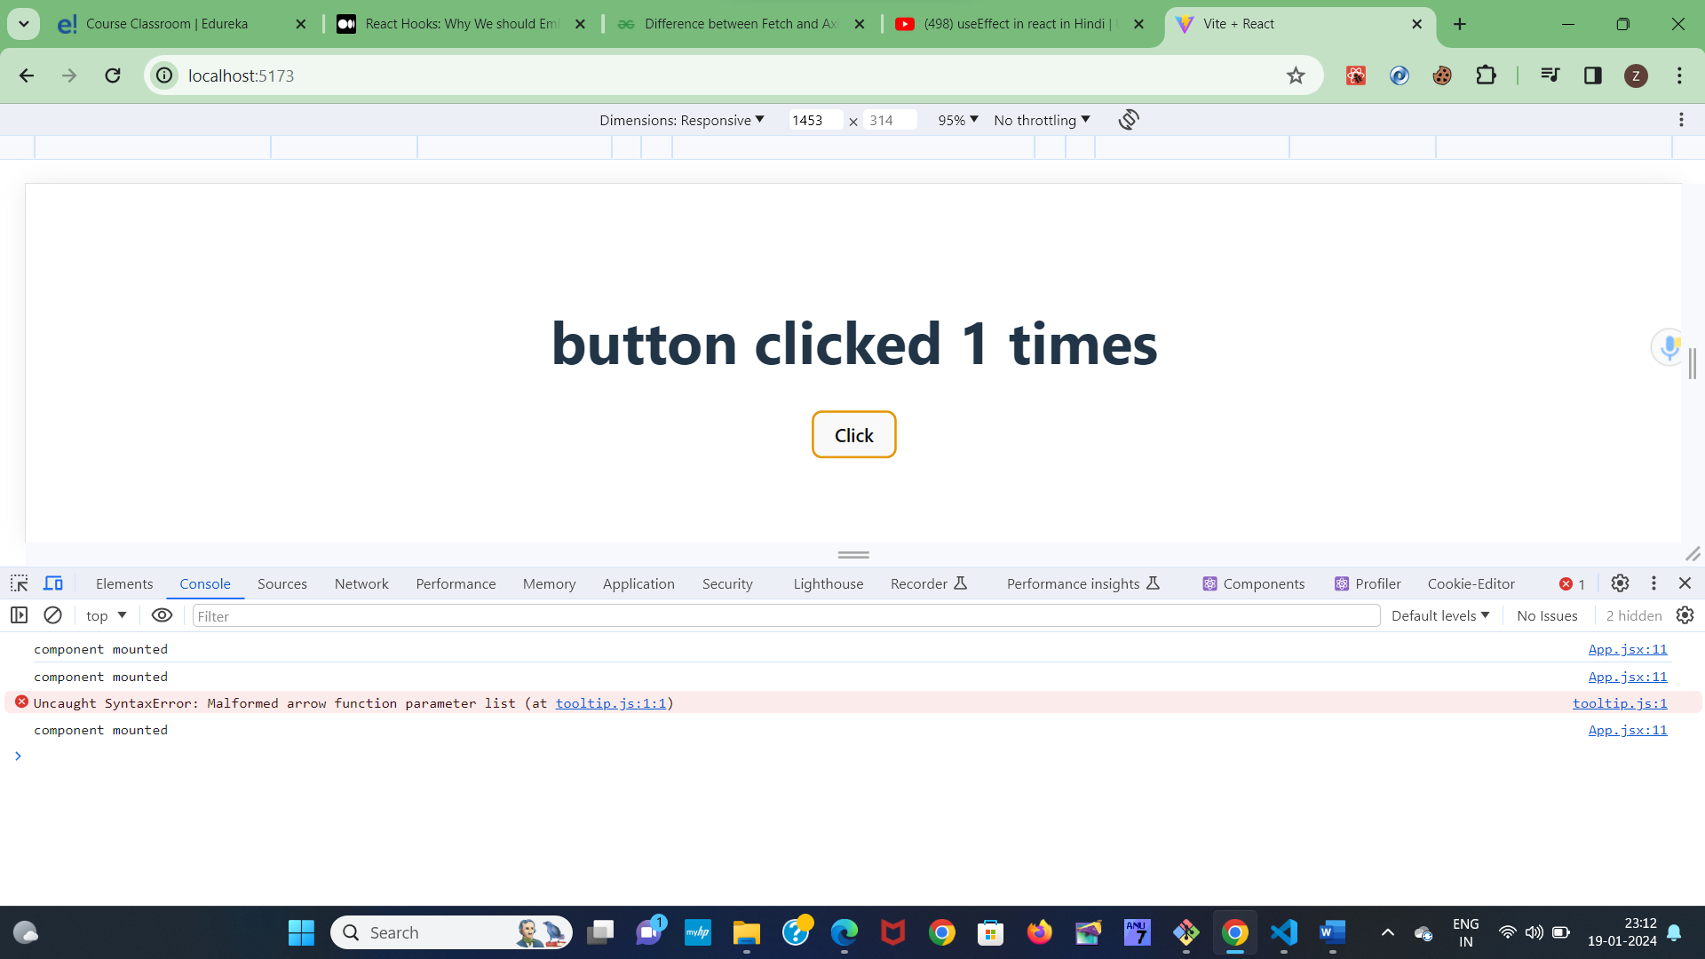

How many times we click the button that many times, useeffect is getting called

It means on updating a state also, the useeffect is getting rendered again

So if I want to not render useeffect on state update, I can pass empty array( or empty dependencies ) as 2nd parameter(optional parameter) to useeffect()

  useEffect(()=>{

    console.log('component mounted')

  },[])

Now check output, useeffect is getting called on only first mount only, not rendering on each update of state

Lets create another state

  const [data,setData]=useState('zee')

    <button onClick={updateData}>update data</button>

  function updateData(){

    setData('zebra')

  }

Now check on clicking updatedata button also, useeffect() is not running, as we passed empty array

Suppose I want to render useeffect() on updating state variable data, but not to render it while updating count.

To do that pass [data] as a dependency 2nd parameter to useeffect()

  useEffect(()=>{

    console.log('component mounted')

  },[data])